**CS 133N – Lab 9 Instructions Name: Amanda Akins**

Complete tutorials 5-4, 5-5 and 5-7 in the text. The textbook author has provided a video illustration of each tutorial at www.pearsonhigehered.com/gaddis. Feel free to view the video to help you do the tutorials, particularly if you miss class. Participate in the Lab questions forum if necessary. For all exercises at the end of the chapters in this course refer to the appropriate peer evaluation for more specific details about what will be required in your solution.

Complete the following two exercise as described.

**Exercise 2 - Problem 4 on page 336**

Write the output to a list box. In addition after displaying the output use a loop to write the contents of the listbox control to a file. Use a SaveFileDialog control to allow the user to save the results wherever they choose. Refer to the peer evaluation for this lab for more details on the requirements.

• Write pseudocode and add it to this document before creating source code.

1. Get starting number of organisms, average daily increase, and number of days to multiply from respective text boxes.
2. For index = 1, index <= days, index++
3. Output table of days and approximate population to listbox.
4. Create StreamWriter object and output file in location of user's choosing

if DialogResult == OK

outputFile = File.CreateText(saveFileDialog.FileName

for index = 1, index < outputListBox.Items.Count, index++

outputListBox.SelectedIndex = index;

outputFile.WriteLine(outputListBox.SelectedItem)

Close file

Display "saved" message

else

Display "cancelled" message

• Add screen-prints of your C# source code and output to this document.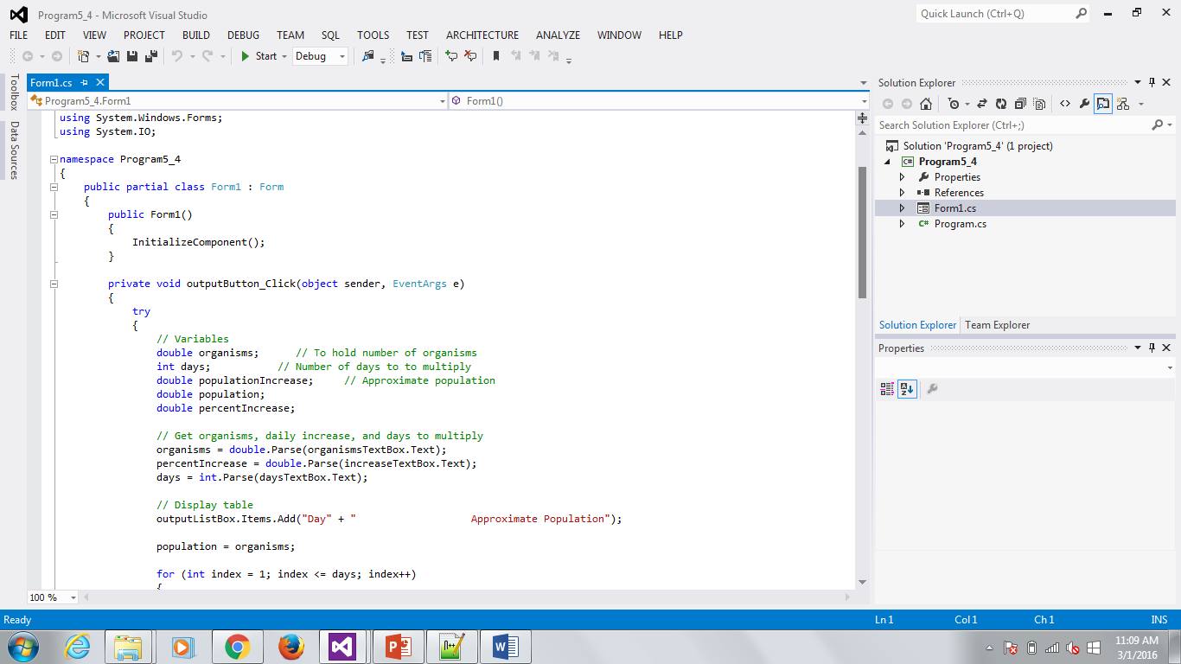

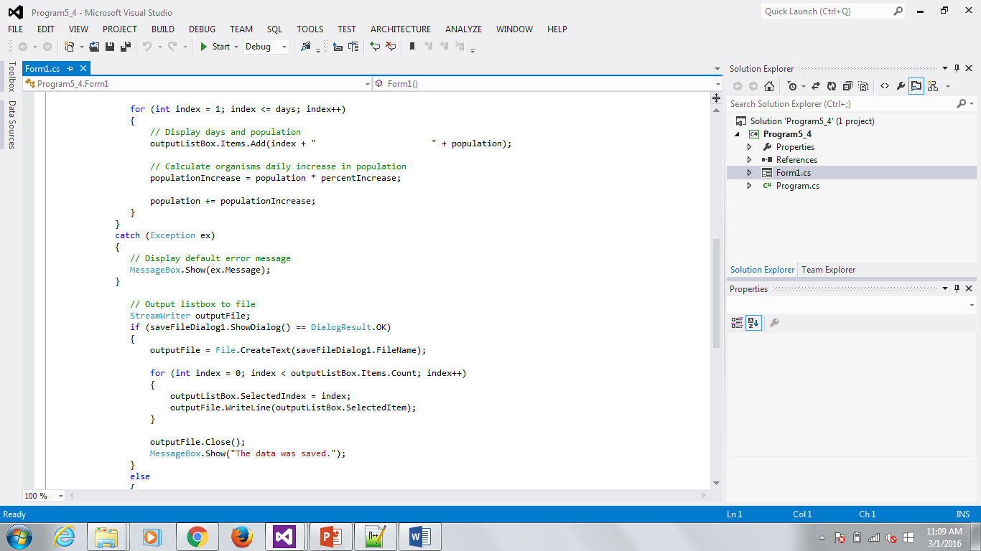

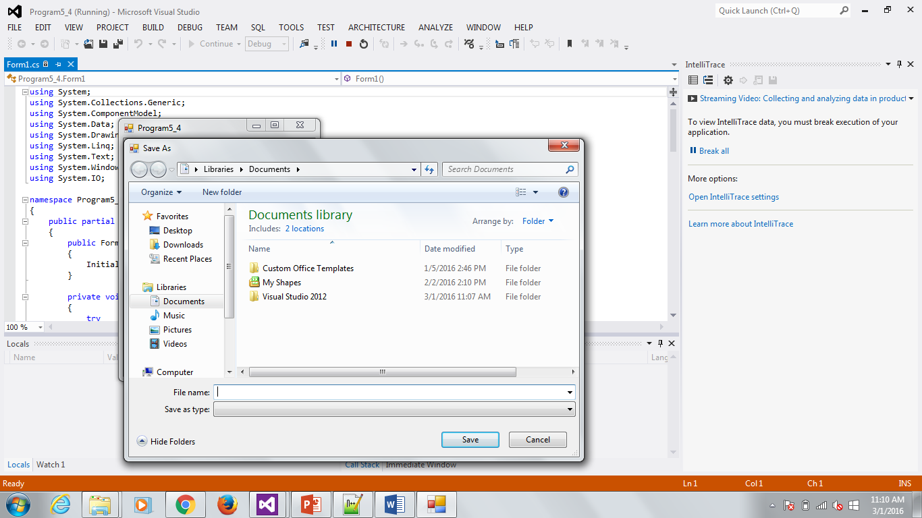

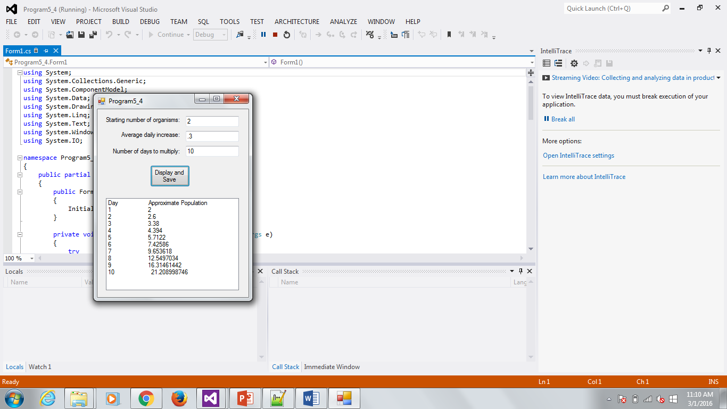

• Be sure to verify that the file your program create has the proper data in it.

**Exercise 3 - Problem 7 on page 337**

Write the output to a list box. In addition after displaying the output use a loop to write the contents of the listbox control to a file. Use a SaveFileDialog control to allow the user to save the results wherever they choose. Refer to the peer evaluation for this lab for more details on the requirements.

• Write pseudocode and add it to this document before creating source code.

1. 3.9 calories burned/minute for 10, 15, 20, 25, and 30 minutes

2. for minutes = 10, minutes <= 30, minutes = minutes + 5

caloriesBurned = minutes * calories

display output

end for

3. Create StreamWriter object and output file in location of user's choosing

if DialogResult == OK

outputFile = File.CreateText(saveFileDialog.FileName

for index = 0, index < caloriesListBox.Items.Count, index++

caloriesListBox.SelectedIndex = index;

outputFile.WriteLine(caloriesListBox.SelectedItem)

Close file

Display "saved" message

else

Display "cancelled" message

• Add screen-prints of your C# source code and output to this document.

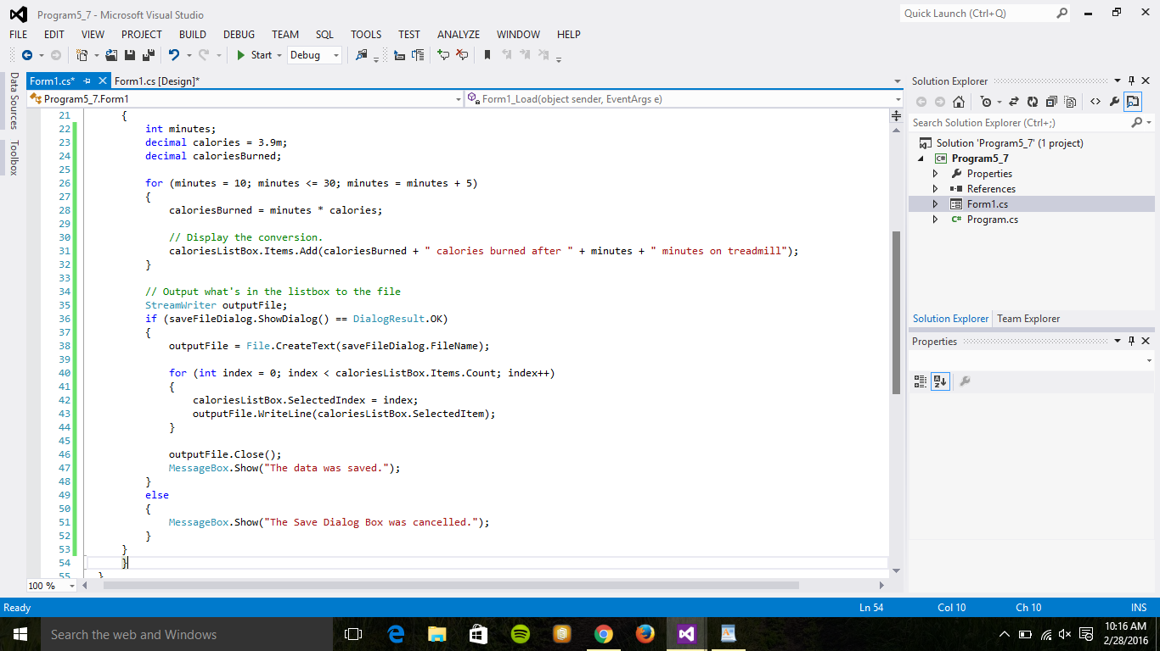

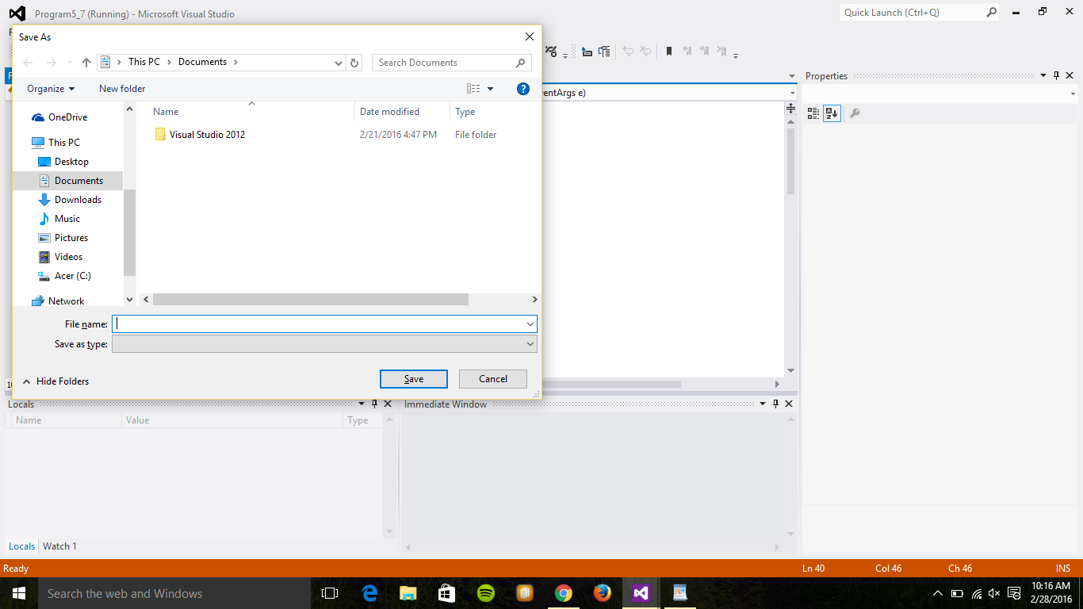

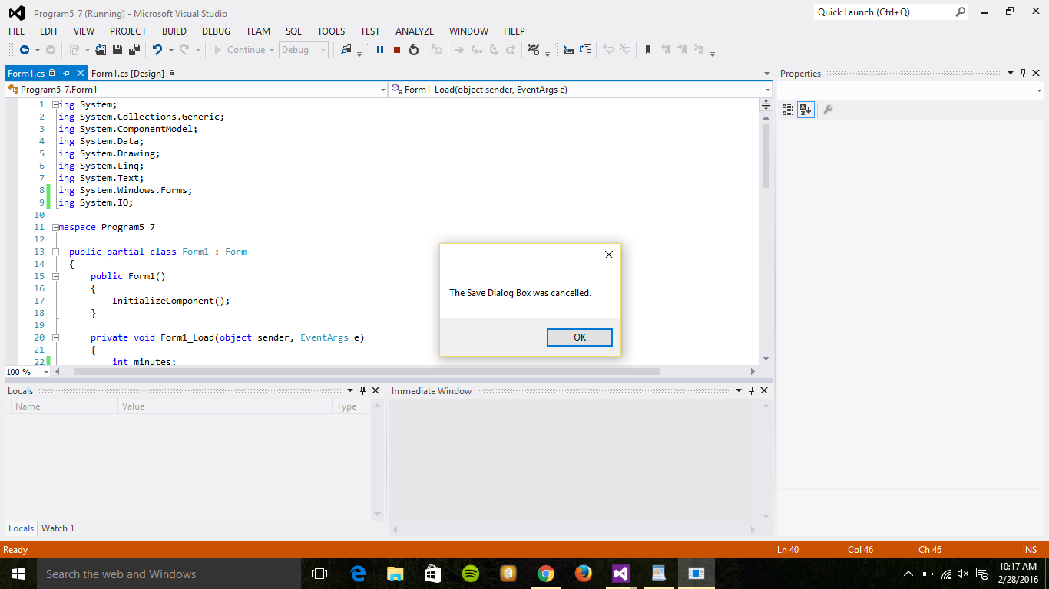

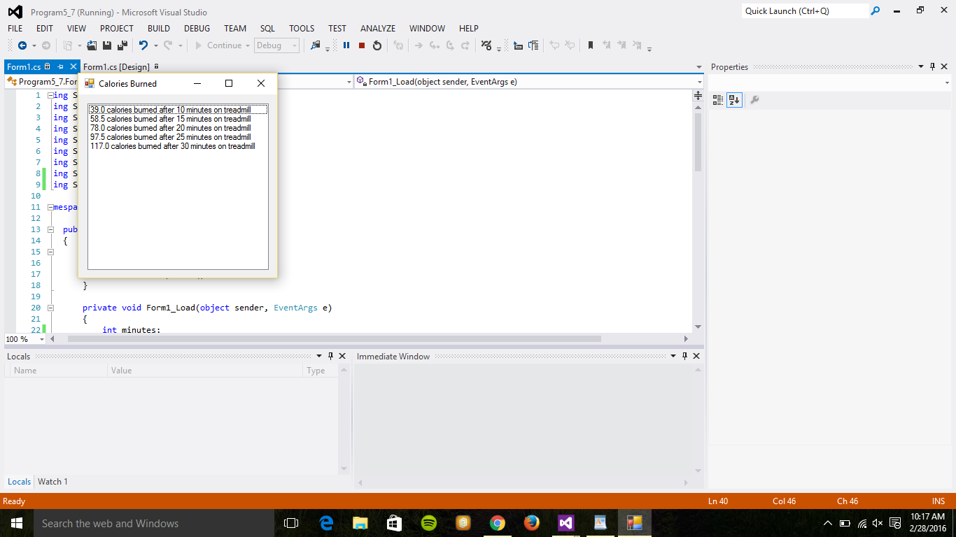

• Be sure to verify that the file your program create has the proper data in it.

Upload this document and the peer evaluation for labs 8 and 9 to the Lab 9 Upload link in Moodle.